Original Image





Image ­Segmentation

K=2:





K=3:

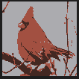



K=4:

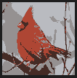



K=5:

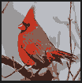

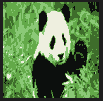

Increasing the number of clusters, makes brings the image closer to the original image as the details become finer and finer. (Time to segment the image also increases with increase in segments)

Image panda “naturally” has 3 clusters but segmenting it into 2 clusters, gives a “leakage of green into white” effect.

Changing the number of iterations and R has no significant effect on the final image.